WEEK 1 SOS4LoveProject 15/1-21/1
High school №11 of the city of Romny Sumy region of Ukraine
6-А class
Teacher Alla Kvashko

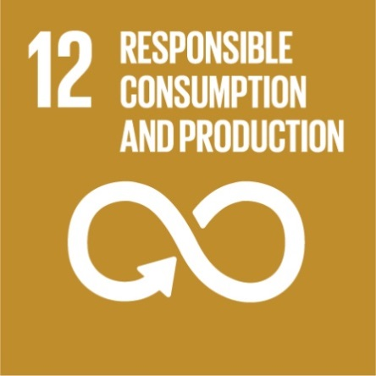

Garbage is a mandatory product of human life. On average, a resident of a big city throws it 1-2 kg daily. In Europe, the record figures of organization can boast Swiss and Germans who do not lynnyuyu carry the electrical elements in one place, glass bottles are thrown into one container, plastic - in the second, paper - in the third, organic residues - in the fourth ... We have to deal with garbage is much worse. Environmental protection and the creation of safe conditions for the vital activity of the population of the country - one of the main tasks officially set by Ukraine
Almost 50% of what we throw in (paper, glass, metal and other materials) is reusable. Unfortunately, most of the waste is still sent to the landfill.
In the process of life, a person does not even want to, but still is the reason that the amount of rubbish increases.
Yet a person can influence the further "fate" of the waste that it throws out. Under any circumstances, the personal attitude of each of us to this problem plays a decisive role in the fight against garbage. First of all, this sorting, according to experts, separating garbage, will reduce to 40% the amount of waste going to landfill.
There is no modern waste recycling plant in Ukraine. 3% garbage is recycled. 97% of garbage is thrown and accumulates.
Therefore, we decided to create a draft action plan and develop a series of measures in line with Goal 12 "Ensuring the transition to rational consumption and production models", which stated that it is necessary to reduce the volume of waste by taking measures to prevent their formation, their reduction, processing and reuse.

Step 1. Introductory lesson. Introduction to the Global Sustainable Development goals 2016-2030. Preparing an action plan.
Step 2. Conducting a training session with the organization "New World";
Step 3. Organize collection of waste paper;
Step4 Organize collection of batteries;
Step 5. Conduct a conversation for 5th grade students about separate garbage collection;
Step 6. Production of containers for separate collection of garbage;
Step 7. Production of handmade products "Second life of spent materials";
Step 8. Organize an exhibition of products;
Step 9. Presentation of the project "Household Waste - Second Life"

I believe that this project will force my students to think that it will be interesting for them and that we will all get there.

GOOD LUCK!
With Loving, Warm Wishes, Teacher Alla Kvashko
r_school_11@ukr.net

