WEEK 1 SOS4LoveProject 15/1-21/1
High school №11 of the city of Romny Sumy region of Ukraine
7-B class
Teacher Tetiana Donets

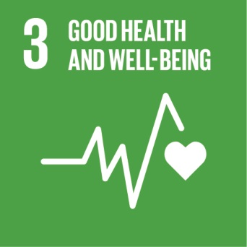
Hello!
One of the Sustainable Development Goals 2016-2030 is to ensure a healthy lifestyle and promote well-being for everybody at any age (Goal No. 3):
"To increase the potential of all countries, especially developing countries, in the area of ​​early prevention, risk reduction and regulation of national and global health risks."
"To improve prevention and treatment of abuse on psychoactive substances, including drug and alcohol."
The goal of the project is to promote a healthy lifestyle, reduce global health risks, inform school students about the dangers of alcohol, tobacco, drugs and their negative impact on the health of young people.
Everyone has the freedom to choose. However, the right choice can only be done by those who are able to answer for their behavior, for their health and for their future.
While you are young you have a healthy body. This gift of nature must be protected. It is easy to lose, but sometimes it's difficult or even impossible to turn back.
A healthy lifestyle will help us to grow healthy, strong, intelligent, happy.
We love Ukraine and we want nobody to lose his life and health because of bad habits.
Project Steps:
1. Understanding the global goals.
2. Making booklets, postcards, holding information events in classes about the benefits of a healthy lifestyle.
3. Conducting a drawing competition "We are for a healthy lifestyle!"
4. Meeting people who live a healthy lifestyle, a doctor narсologist of the First Regional Mental Specialized Hospital.
5. Creating a slideshow "We support a healthy lifestyle!"
GOOD LUCK!
With Loving, Warm Wishes, Teacher Tetiana Donets

r_school_11@ukr.net

