SOS4Love Project
MISSION AGAPE REPORT
«SUPPORT THE LOVE FOR PEACE»
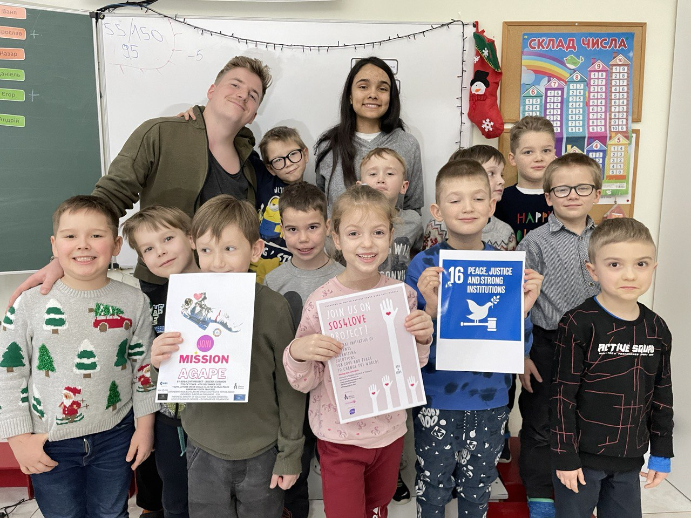

1) School/Organisation/Country:
Joy School, Vyshgorod, Ukraine
nicksteppe@gmail.com
https://www.facebook.com/JoySchoolVishgorod
2) Teacher or Youth Participant Name & Last Name - Subject taught in class if Mission AGAPE action takes place in school/university context:
MR Sofiia, teacher of the 1st grade in primary school
Dima Moshkivskii, tutor
Children taking part in the project
- Yehor Andrienko
- Ivan Babin
- Myron Bodaniuk
- Vsevolod Brovar
- Heorhii Vezhnin
- Andrii Davydenko
- Mykyta Denysov
- Marianna Didukh
- Arina Zaporozhchenko
- Daniel Kahan
- Yaroslav Kechik
- Kateryna Lialka
- Artem Ruschak
- Nazar Shamonin

3) Describe your Mission AGAPE Action in brief and its results.
UN goal №16 «Peace, Justice and Strong Institutions»
Name of the project – «Support the love for peace».
Purpose: To teach every child to support those who are in trouble and to bring peace to other people's lives.
- The teachers familiarized the 1st grade students with the UN goals. They chose goal №16 «Peace, Justice and Strong Institutions».
- Children discussed how they can support and bring peace to people who are in trouble.
- Students have collected Christmas presents.
- Children presented gifts to families who moved to our city from the active war zone. People from whom the war took everything: relatives, friends, housing, clothes, savings.
- Children are happy because they were able to give love, support and peace to those in need.
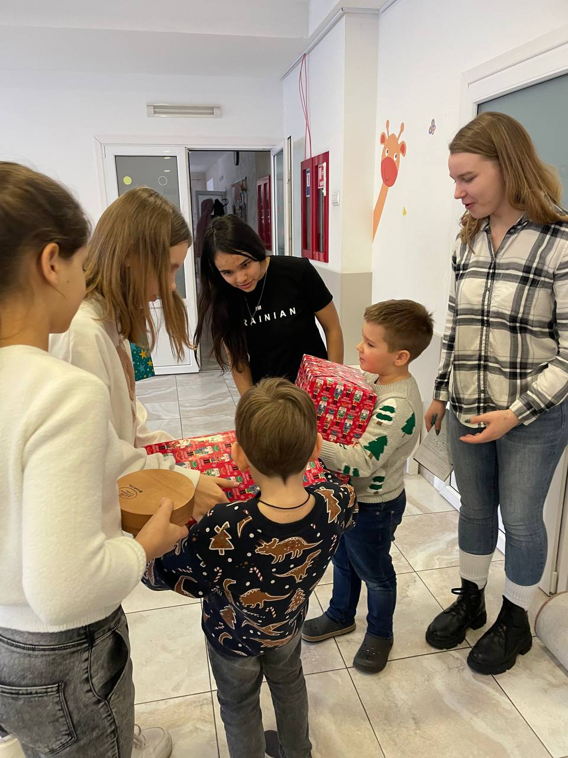
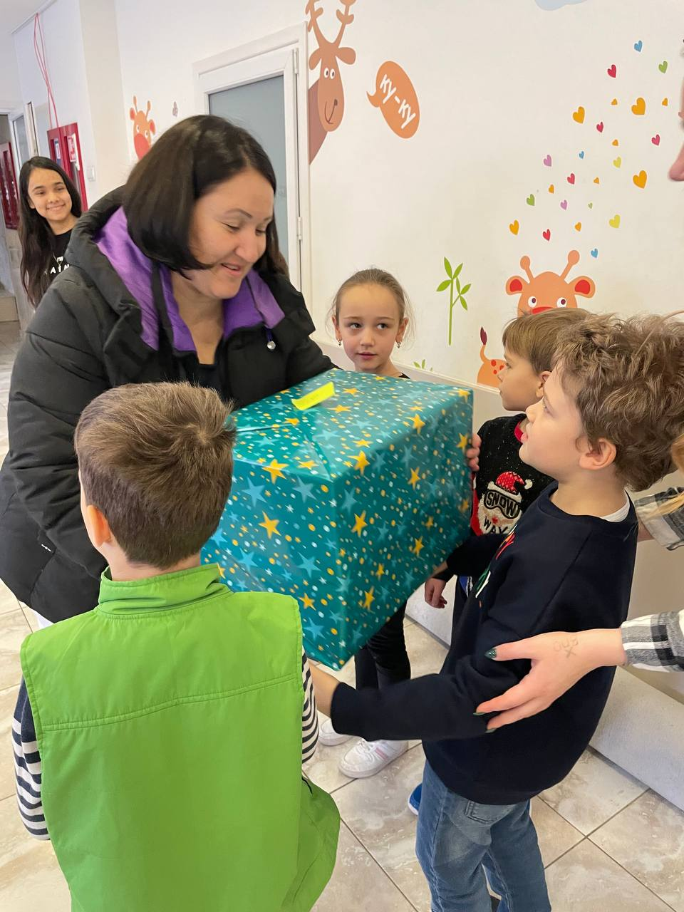

More photos in the 2nd part of the report

4) Share your feelings and reflections on your experience throughout MISSION AGAPE as well your impression on the innovative Space Tool-Kit: ‘ACT like a Cosmo-Astronaut for a New Earth of Peace’ and the ‘SOS4love Goes to Space for SDGs’ App.
We were glad to take part in this project. Both children and teachers were to united to reach our goal and give a piece of comfort and peace to those who are in need. We feel united and encouraged because we had great opportunity to share our love with people!

5) Which of the following special skills and ethos of the Cosmo-Astronauts you believe students/youth had a chance to cultivate throughout your MISSION-AGAPE Action? Highlight the ones that apply to you: Adaptability, resilience, physical condition, mental endurance, leadership, scientific scrutiny, communication skills, out of the box thinking, synthetic and analytical thinking, imagination, creativity, ethos of respect, problem solving, work under pressure, ability to make detailed observations, proactiveness, multi-tasking, ability to focus on following procedures, robotics, repair skills, teamwork, ethos of working for the benefit of all, ability to see the BIG Picture.

