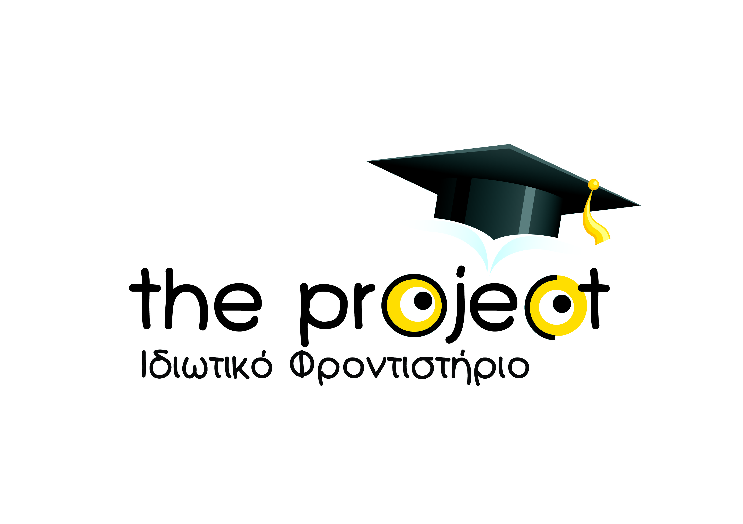

There has been a worldwide discussion going on regarding gender equality -GOAL 5- due to the recent outbreak of sexual harassment scandals in the United States. Here, in the small country of Cyprus, we firmly believe we can effectively address the issue of gender inequality head-on, as it is widely present at schools, homes and workplaces. It is a well-known fact that the rate of domestic violence is considerably high. As a private institution, the Project wants to let students know that both men and women share the same rights in all aspects of life, and that it is important for their generation to change the mindset of the Cypriot society by supporting this perspective.

Steps:
- We asked our students to think about whether they have ever been bullied due to their gender.
- We gave them real-life examples.
- We asked them to think about what their answer would be if they were part of situations such as those presented to them.

Difficulties:
- The students had never really thought about gender-based violence before. Nobody had ever explained to them that all genders share the exact same rights and that there is indeed a gender inequality issue in their country.

The Project
Dr. Olga Kanelli - Director of Studies
Miss Theodora Kontou- English Teacher
Miss Natalie Kyprianou- English Teacher
Ιδιωτικό Φροντιστήριο
Λευκωσία Κύπρος
www.theproject.com.cy

