Teachers – Facilitators of SOS4Love Project
‘PLASTIC, BIODEGRADABLE, OR FABRIC BAG?
Which one would you choose to carry your groceries?’

Efi Dariou¹, Marianna Ioannou², Stella Timotheou³, Maria Vasiliou⁴

Collaborating schools: 1: Agios Spyridonas Strovolou Primary School, 2: Katharis Primary School – Dimitris Lipertis, 3: B’ Ormideias Primary School, 4: Parekklisia Primary School, Cyprus

 | Efi Dariou is working as a teacher in Government Elementary Schools since 2003. Now she is working at Agios Spyridonas Primary School in the capital of Cyprus, Nicosia. She collaborates with several teachers across Cyprus for the designing and implementation of Environmental Programs to support Sustainable Development in Cypriot schools. She received her BSc Hons. in Education from Democritus University of Thrace, Greece in 2003 and her BSc degree in Civil and Environmental Engineering from the University of Cyprus, in 2011. She received her MSc (Dist.) in Education for the Environment and Sustainable Development from Frederick University of Cyprus in 2014.
Efi Dariou
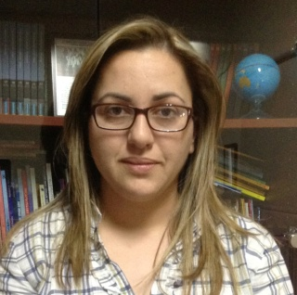 | Marianna Ioannou is an experienced teacher with 18 years of working in the primary education industry. Now she is working at Katharis Primary School in Larnaca. She is interested in E-Learning, Environmental Learning. She has a Bachelor's degree focused in Interactive Multimedia from MA - Cyprus University of Technology and a Bachelor's degree focused in Linguistic and Cultural Education- Aristotle University of Thessaloniki. Currently, she is a PhD candidate at the Department of Multimedia and Graphic Arts - Cyprus University of Technology.
Marianna Ioannou
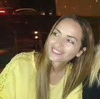 | Stella Timotheou is working as a teacher in Cyprus’ Elementary Schools since 2000. Now she is working at 2nd Ormideia Primary School in Larnaca. She took her bachelor’s degree from the School of Education at the University of Cyprus in 2000 and her master’s degree from the Department of Communication and Internet Studies at the Cyprus University of Technology in 2017. Now she is a PhD student at the School of Multimedia and Graphic Arts of Cyprus University of Technology.
Stella Timotheou
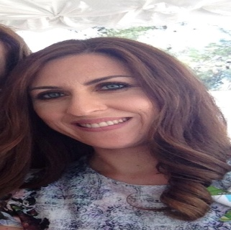 | Maria Vasiliou is working as a teacher in Government Elementary Schools in Cyprus, since 2003. Now she is working at Parekklisias Primary School in Limassol. She received her BSc Hons. in Education from the University of the Aegean in Rhodes, Greece, in 2003. She received her MSc (Dist.) in Educational Leadership and Policy, from the Open University of Cyprus in 2008.
Maria Vasiliou

