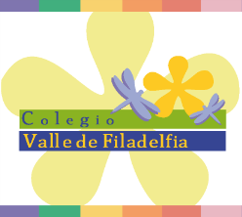
# SOS 4 LOVE PROJECT
2019
WEEK 2 REPORT

School: Colegio Valle de Filadelfia Aguascalientes
Country: México.
4TH GRADE STUDENTS
Teacher: Miss Luz González R.
Photos of our SOS4loveProject Action
Students are creating posters, to share their ideas about how to spread love and help the world, after talking about SDG #6 situation; clean water and sanitation.
