SOS4Love Project
Final Report
Please complete & email to info@sos4loveproject.com
during the 4th Week Report, 28th to 31st ^{th} of October 2019
School/Country:
Escuela Secundaria Rodolfo de la Colina (Rodolfo de la Colina High School)-ARGENTINA
Teachers/Facilitators:
Ms. Gabriela Andrea Gallardo (teacher)
Mr. Roberto Carlos Chiumiento (teacher)
Ms. Silvina Grande (Headschool)
Ms. Andrea Komaid(Pedagogical Advisor)
Subject:
“Social Insertion and Development Project” & Geography

1) Please provide answers to the following questions:
a) Define the CHALLENGE/problem that inspires/inspired your heart to take action and explain why it inspires/inspired you.
“We live in El Manantial, Lules in the North West region of Argentina. This area is mainly agricultural where people grow fruits and vegetables. Our lemons are internationally famous, as well as our blueberry and strawberry. We have high quality soil around here, but sadly some areas are highly contaminated because the water used for plantations usually come from factories, or wasted water.
b) What is the specific SDG or SDGs (it can be one or more ) that you support and is connected with your Action?
We support SDG N° 12 - “RESPONSIBLE CONSUMPTION AND PRODUCTION”
Be sure to describe:
- your IDEA (how you think you can or have already contributed to the SOLUTION of the challenge/problem?
The problem of contaminated irrigation water is the reason why we decided to teach our students how to grow an Organic Garden and how to make organic fertilizers and pesticides by their own in order to get healthy vegetables. Another reason is the economic crisis in Argentina which urged us to look for food solutions and / or a job opportunity for those who are unemployed. We strongly think and hope our students will use the know-how and help their families in times of need.
- STEPS (what actions you will take or have taken to turn your idea into positive ACTION)
Step 1: We chose the best place in the school where the soil would be ideal for working on our Organic Garden; took out from the soil everything not organic like plastic, metal, paper and so on; stirred up the soil to get the nutrients to start sowing. We looked for the assessment of experts from INTA (Instituto Nacional de Tecnología Agropecuaria- National Institute of Agricultural Technology ) who gave us very significant advice that has helped us organize our project since then.
Step 2: We prepared the soil, fertilized it with dung, planted the seeds, made organic pesticides from garlic, alcohol and tobacco leaves, planted basil in the corners of the garden as natural repellent for certain pests. And we looked anxiously for our first plants to appear!!
Step 3: We harvested and sold the products among students and teachers, and with the money collected we bought tools to improve our work.
Note: These steps are repeated year after year with certain improvements in tools and know-how.
Step 4: Other schools contacted us looking for assessment and now we are starting a new step in our project: Training other Tucumanian students and spreading LOVE for our “soil”, Planet, families and friends in need.
- the DIFFICULTIES (the specific challenges you may face or have anticipated and how you have or plan to overcome them)
At first, during 2016, we found it difficult to wait for the results. We expected our harvest to pop up magically but later on we realized that we had to understand “the natural cycle of live in plants” and used that time for studying about the vegetables and fruits that would grow fantastically in this area of the country. We learned from those more experienced than us and from experts. Meanwhile we planned future activities to start once we obtain the products and according to the quantity obtained as well.
2) Share the results of your SOS4Love project.
We found that we have achieved:
- To acquire a high sense of belonging from students towards the school and its activities like this project among others.
- To organize a school function to promote self-employment and microbusinesses.
- To learn how to make jam, desserts, mayonnaise and others from the organic garden products.
- To love nature and respect its cycles, times and needs.

3) Share your feelings and reflections on your experience throughout the SOS4Love project.
This Organic Garden Project which has started in 2016 in a small piece of land within the school property has led our students, families and teachers to LOVE our school, our province and has taught us that if we really care about the environment we will get in return healthy food, healthy air, self-employment, friendship, cooperation, solidarity and empathy.
There are national surveys that show the harmonious institutional environment that our teachers and students have built in our dear La Colina High School.

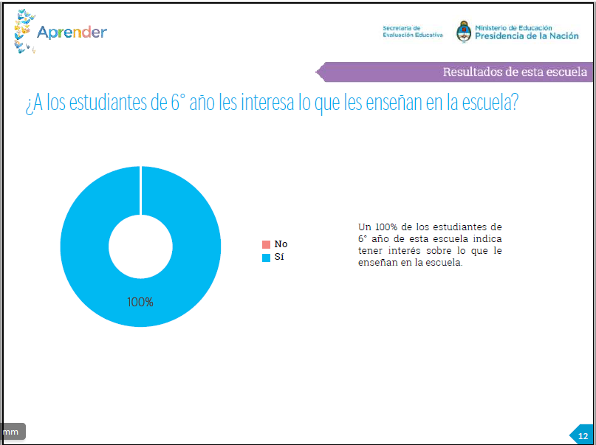
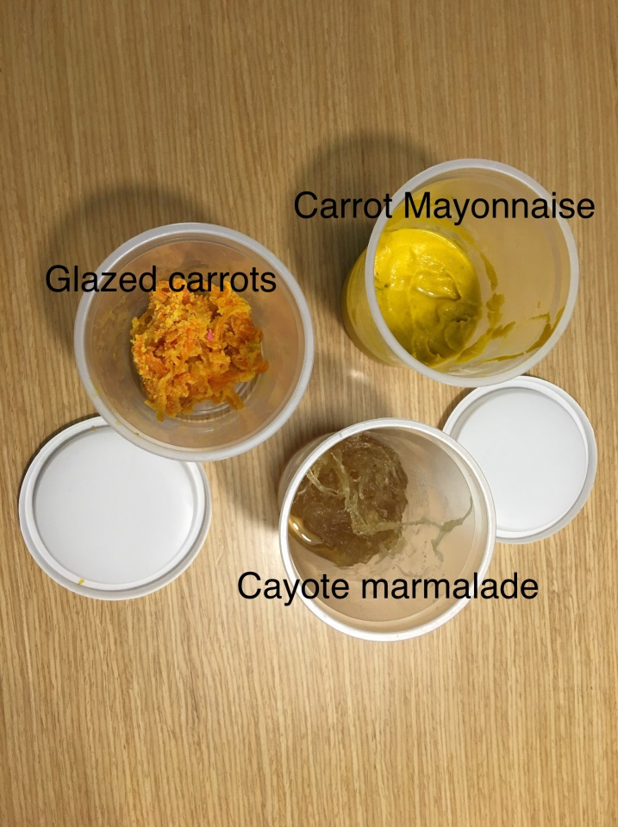
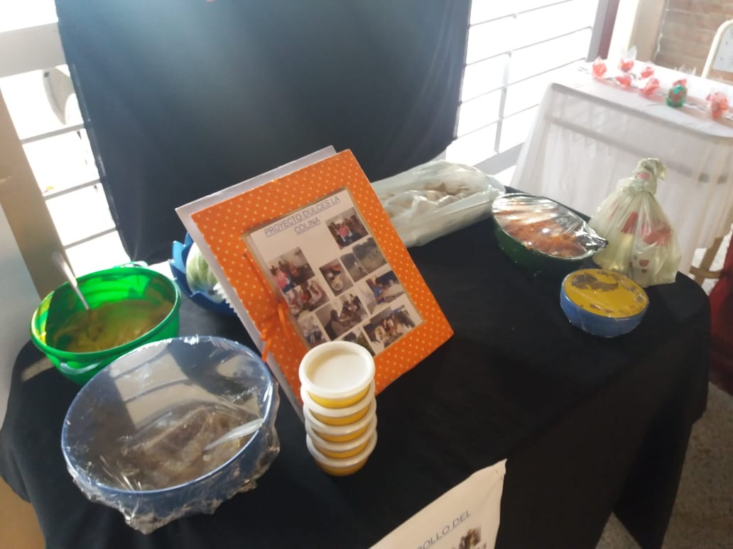 School Function
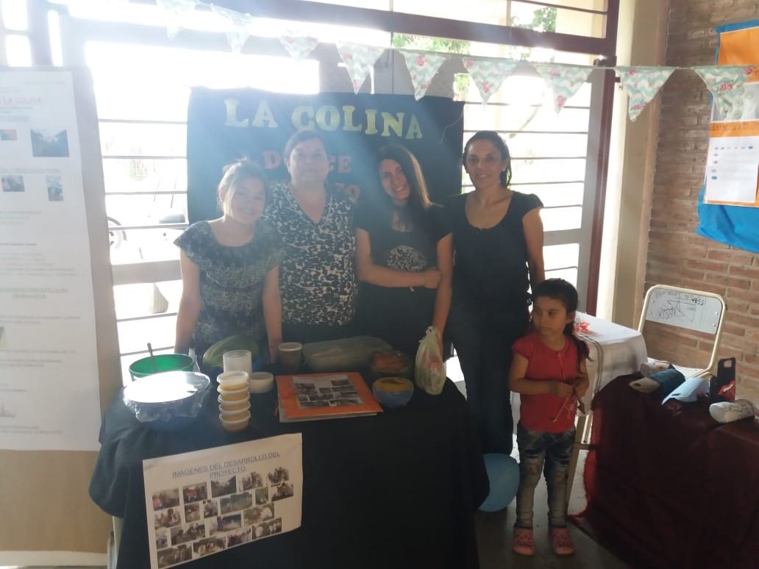 School Function

Thank you for Acting 4Love World-Changers! Looking forward to seeing you next school year in the SOS4Love Project again, to Keep Changing the World Together with #Pedagogy4Love!

