Juan Bautista Alberdi Normal School Higher in Living Languages
Initial Level: 5-year room section “A” Afternoon Shift
Teacher: Myriam Elizabeth Sánchez
Subject: Report on the work related to Dengue
The topic I chose was related to Dengue, due to the epidemic in our province. It was the year in which more cases were registered and I considered studying it due to the importance of the prevention of this disease.
The objectives of the project were that the children get to know the disease, the symptoms it produces; identify the mosquito, its appearance. Also its life cycle, its stages, its reproduction and raise awareness among children about prevention, the use of repellent, and the importance of discarding funds from their homes.
As for the activities, an investigation was carried out with the help of the family, they drew the mosquito by placing the names of the parts that compose it, they also made a model imitating the mosquito, they carried out its life cycle, its reproduction from birth to becoming adult, they investigated their habitat, where they live, etc.
Regarding prevention, they drew the places and objects where mosquitoes lay their eggs, they made posters with phrases on how to prevent the disease, and they placed them in businesses near their homes. They learned a poem "El mosquito Lito" and danced with their parents the "Tango del mosquito".
It was a beautiful experience as the great commitment of the family and the enthusiasm of the children was noticed when telling about the mosquito and the disease through videos, posters explaining the life cycle and its prevention. They felt very important as they informed the traders what they have learned. (Experience told by parents)
In this project, all the proposed objectives were achieved, since there was a true awareness and participation with responsibility of the whole family.

Here the children drew the mosquito and its parts.
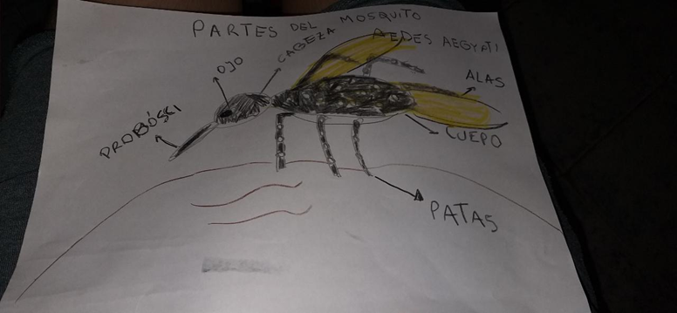
Also they made a model of the mosquito with wire, cardboard, tissue paper, glue, paint.
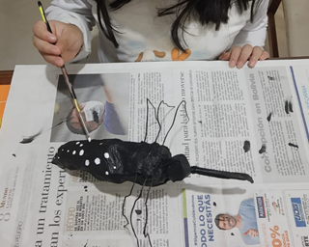
Also they made a model of the mosquito with wire, cardboard, tissue paper, glue, paint
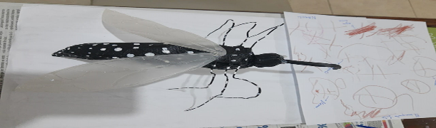
They born from eggs, after 3 days they are larvas, and then in five days they evolve to Pupa. Finally, in 1 or 2 days start the adult age.
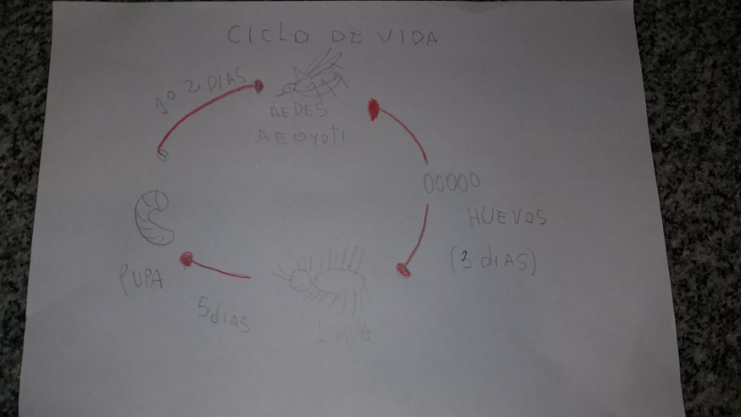
The mosquito lays its eggs in clean water, just a cap of a soda bottle is enough for it to lay its eggs.
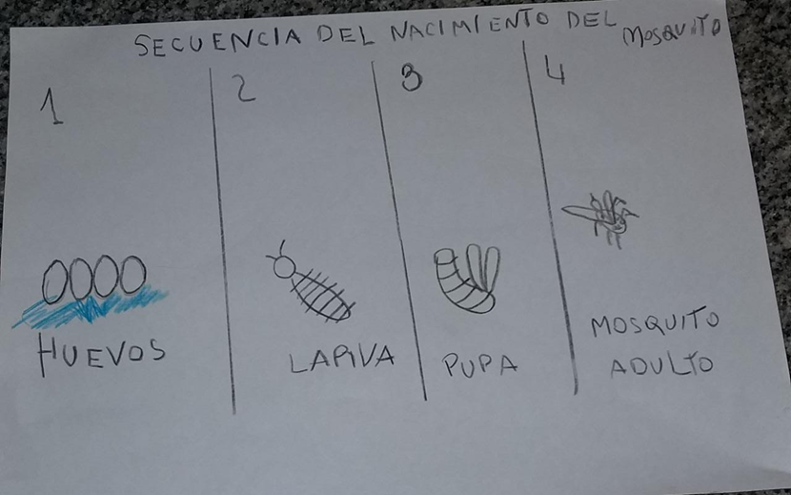
Then through posters the children wrote how to prevent this disease:
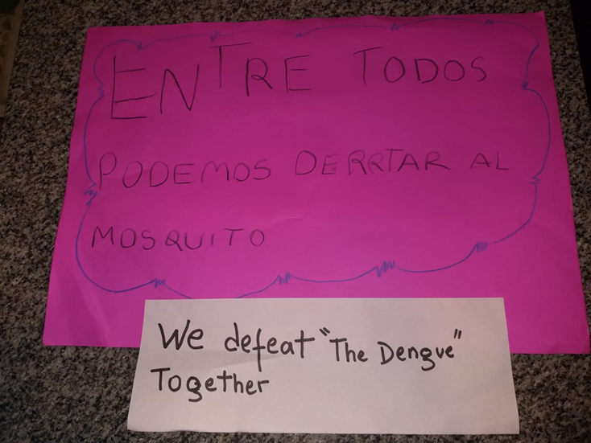
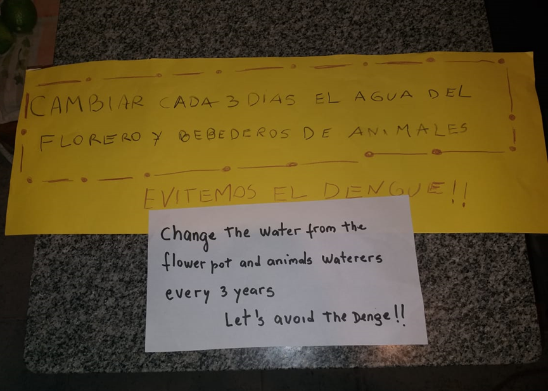
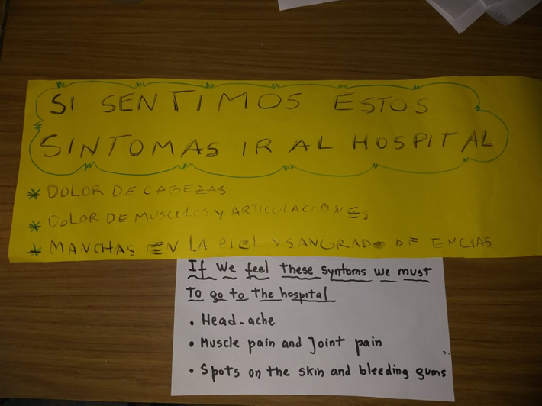
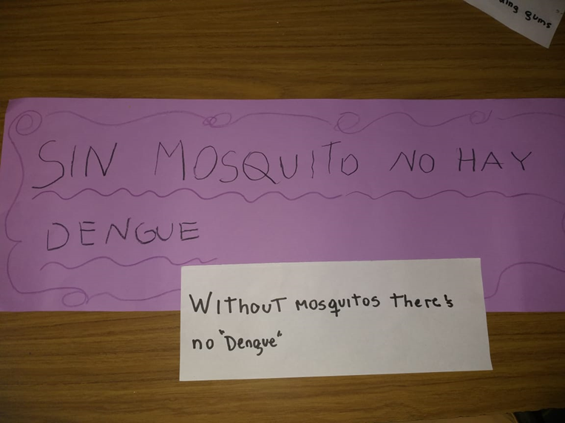
In this way the project culminated. I am very satisfied, since the family committed to enhance it with responsibility and great participation on the part of the children. It was a beautiful experience
