The following plan was elaborated by the students of Agrupamento de Escolas Dr. Alberto Iria, in Olhão, Portugal, with the help of their English teacher, Lúcia Nassa Tardão

The problem:
The Algarve is well known to tourists due to its amazing beaches; however this Portuguese region hides a real natural paradise where fauna and flora coexist in perfect harmony with fishermen and their typical houses.
Nature reserve since 1978, Ria Formosa became a natural park in 1987. This new status gave this place the means to better protect and keep the lagoon system, flora and fauna and, this way, protect the migratory species and their natural habitats. However, this Nature reserve is exposed to pollution caused by many sources which damage all living species and can cause their disappearance. It is our intention to explore the species living in the Ria Formosa water marshal, understand to what extent they are being damaged by water pollution and launch a local campaign to stop pollution.

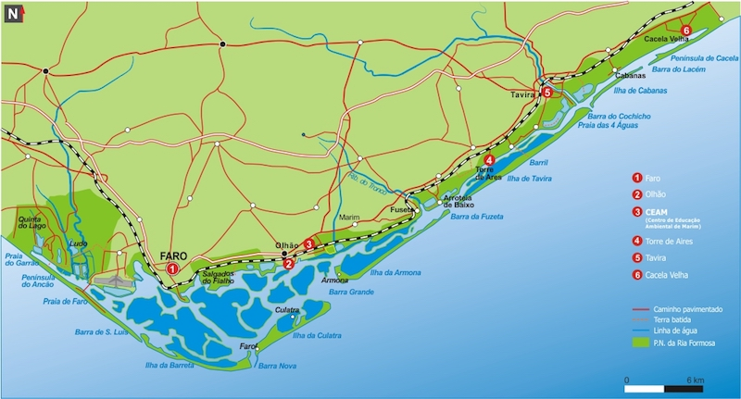

The Sustainable Development Goal:

We want to address SDG no. 14 and understand to what extent the species living in our Ria Formosa are being damaged by water pollution. At the same time we want to relate this to SDG no. 13 and find the reasons why water pollution is correlated to Climate change.

Step 1: Visit Ria Formosa Natural Park, take pictures of the polluted areas and at the same time do some cleaning action.
Step 2: Study the species in Ria Formosa and investigate to what extent they are damaged by water pollution.
Step 3: Organize workshops to explain to other colleagues in different classes about what should be done to avoid water pollution;
Step 4: Publish some videos and leaflets against water pollution and, consequently, how to refrain climate action.

Step 5: Organize an exhibition with all the researches and papers done by the students.

Difficulties: We expect to have some but we hope to overcome them as we pursuit our goal.The main problem is the lack of time. Students will have to work on their own, during their free time to overcome this problem. Another problem is to measure the impact of our action; this difficulty we will try to overcome by evaluating amongst our colleagues (500 students) what they have learnt with our work.

