WEEK 1 SOS4LoveProject 15/1-21/1
High school №11 of the city of Romny Sumy region of Ukraine
7-А class
Teacher Lyudmila Mel’nik

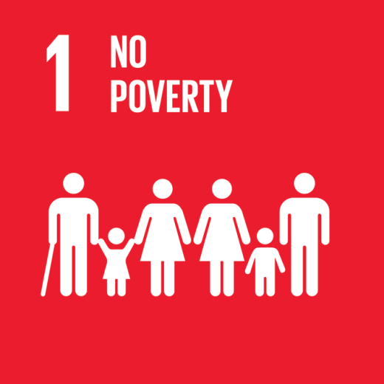
Hello!
Having acquainted with the Global Sustainable Development Goals, the 7th grade students were particularly interested in Goal No. 1 "Overcoming Poverty". Therefore, there was a desire to investigate this problem in more details. Poverty is one of the main problems of the modern world. The purpose of students` investigation was material poverty, because it is precisely the root of many social and economic problems in the state, because it exactly humiliates and depresses people, limits a person to self-realization. During the discussion, the students agreed that a materially poor person could be spiritually rich. We often meet such people, they live near us and we cannot be indifferent to their situation. Being at the poverty line is possible for various reasons, for example, through unpredictable living or natural conditions. But whether it's important to look for a reason, you need to act! We have to do something to help poor people. After all, when a person feels pain - he is alive, and when he feels the pain of others - he is a man. Let's be kind and merciful to each other!
Goals in action.
Step 1
To get acquainted with the global goals in details, paying special attention to problem number 1 and its dissemination in the world and in Ukraine. To look through statistical materials and identify the extent of poverty in the country. To meet Nina and Yaroslav Yaroshenko, missionaries, teachers who have been living in Africa for a long time. They can share their experiences about the peculiarities of the life of the African population and the experience of solving the problem of poverty and hunger in Kenya.
Step 2
Each participant of the project, bringing parents to cooperation, will analyze the situation in the nearby area and identify the needs of people in difficult material conditions.
Step 3
To discuss the gathered information and hold the discussions of the ideas as to the possible ways of helping people who need it.
Step 4
To collect office supplies and books that are needed to educate children from low-income families who are studying in our class.
Step 5
To help the family that has fallen into difficult conditions as a result of a fire by collecting warm things, hygiene products and pocket money for the child at school.
Step6
To collect foods for cooking in the local church.
Step 7
To visit the local children's department of the mental hospital and give the sick children toys, educational games and children's books.
Step 8
To write a small essay on poverty, sharing your own experiences from the work.
Difficulties
While working on a project, the greatest difficulty can be the communication with people who we are willing to help. We are to pick up words not to offend a person, in any case, not to stress the problem of poverty, but to support, reassure and inspire hope and love for a better future.
GOOD LUCK!
With Loving, Warm Wishes, Teacher Lyudmila Mel’nik

r_school_11@ukr.net

