Teachers – Facilitators of SOS4Love Project
‘PLASTIC, BIODEGRADABLE, OR FABRIC BAG?
Which one would you choose to carry your groceries?’

Efi Dariou¹, Marianna Ioannou², Stella Timotheou³, Maria Vasiliou⁴

Collaborating schools: 1: Agios Spyridonas Strovolou Primary School, 2: Katharis Primary School – Dimitris Lipertis, 3: B’ Ormideias Primary School, 4: Parekklisias Primary School, Cyprus

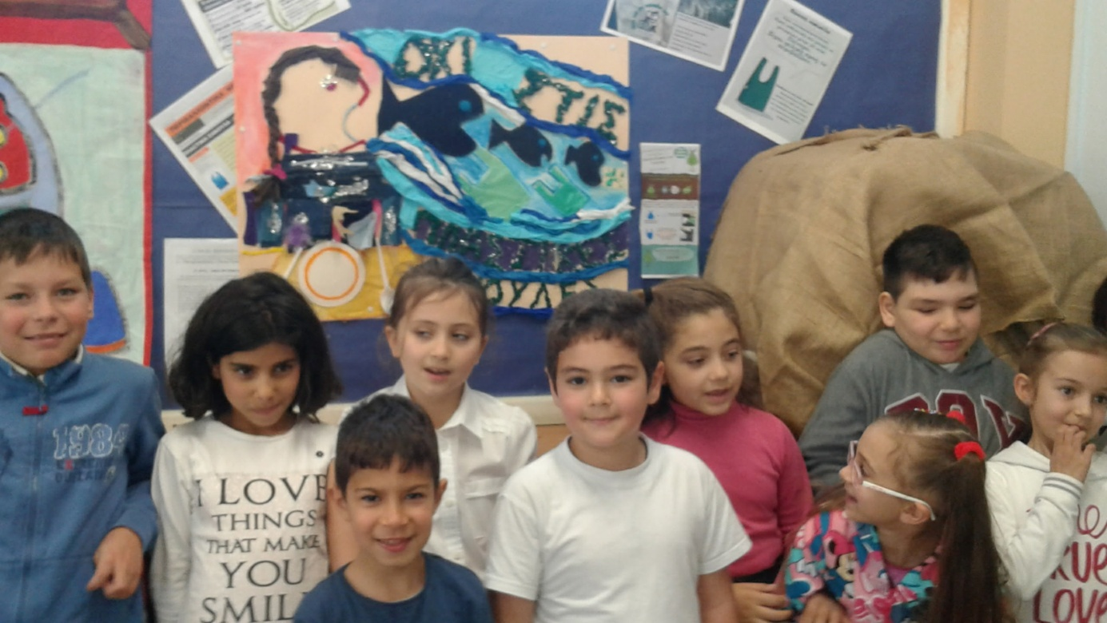
Agios Spyridonas Strovolou Primary School
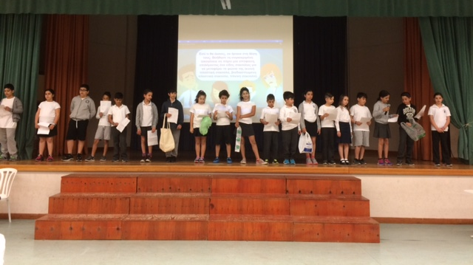
Katharis Primary School – Dimitris Lipertis
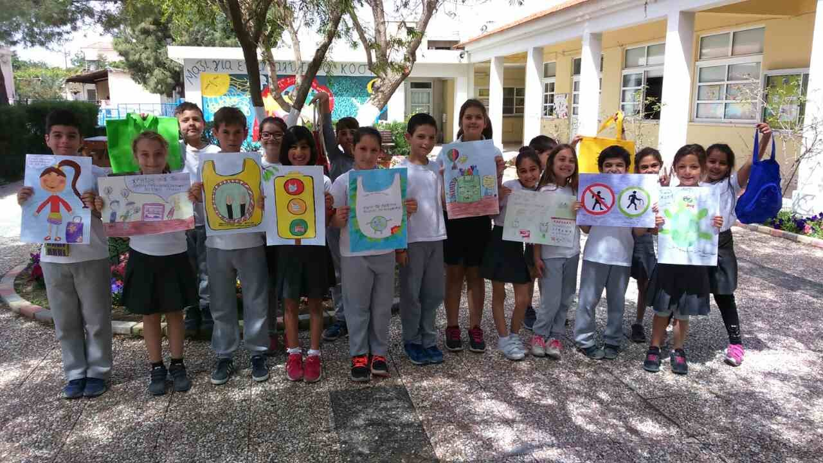
Parekklisias Primary School

