WEEK 1 SOS4LoveProject 15/1-21/1
High school №11 of the city of Romny Sumy region of Ukraine
3-А class
Teacher Lesia Papiy

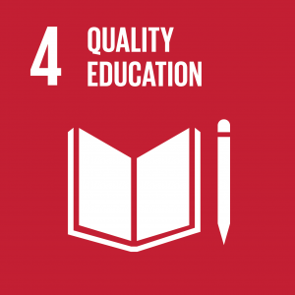
Hello!
In our city there are many children who belong to vulnerable groups. These are children with special needs. They do not have the opportunity to attend regular educational institutions for health and receive high-quality education. This problem is mentioned in one of the global sustainable development goals 2016-2030 under No. 4: providing comprehensive and equitable quality education and encouraging lifelong learning opportunities for all. Therefore, training sessions for them are organized at the Romny Social Rehabilitation Center for disabled children. Special babies lack communication with their peers, love and warmth. Very often the reaction of others to such children is inadequate. Children who look and behave differently, attract attention, as well as everything unusual. But what do they feel about this? First of all, they are just children, full of personality. Only, by virtue of their condition, they live and perceive the world in a different way. Therefore, the pupils of the 3rd grade were concerned with the problems of these children from the rehabilitation center. We believe that these children need love and care as nobody else. In order to attract public attention and solve this problem, we propose the following steps:
Step 1. Introductory lesson. Introduction to the Global Sustainable Development goals 2016-2030. Preparing an action plan.
Step 2. Preparation of the performance for St. Nicholas Day (distribution of roles, rehearsals, making costumes).
Step 3. Performance in Romny rehabilitation center for disabled children.
Step 4. Collecting stationery, interesting literature for disabled children.
Step 5. To present children a book bird-house and literature for it.
Step 6. To dress like angels and to conduct a survey among children of grades 1-4 of our school on how they give love to their relatives and friends.
Step 7. Make an exhibition of drawings in your school on the topic "Give Love to Everyone".
Of course, working on this problem, there may be some difficulties. We will have to master the basic principles of etiquette in communication with children with disabilities, to choose an individual approach, taking into concideration the peculiarities of each particular child. Also, we will have to understand how to communicate with them and how to behave in their presence in order not to injure by tactlessness or incomprehension.

GOOD LUCK!
With Loving, Warm Wishes, Teacher Lesia Papiy
r_school_11@ukr.net

